# Assignment 1(A):

Aim: Write a program to create a robot to perform rectangular motion using gears

Description:

1. NxtRobot() :

Class that represents a simulated NXT robot brick. Parts (e.g. motors, sensors) may be assembled into the robot to make it doing the desired job.

1. Gear() :

Creates a gear instance with right motor plugged into port A, left motor plugged into port B.

1. addPart() :

Assembles the given part into the robot.

1. setSpeed() :

Sets the speed to the given value (arbitrary units).

1. forward() :

Starts the forward movement for the given duration (in ms) and stops. Method returns at the end of the given duration.

1. left() :

Starts to rotate left (center of rotation at middle of the wheel axes). Method returns immediately, while the movement continues

Code:

import ch.aplu.robotsim.NxtRobot; import ch.aplu.robotsim.Gear; public class assignment1A {

public assignment1A() { NxtRobot r = new NxtRobot (); Gear g = new Gear();

r.addPart (g); g.setSpeed (100); while (true){

g.forward (800);

g.left (280);

}

}

public static void main (String [] args){ new assignment1A ();

}

}

# Output:

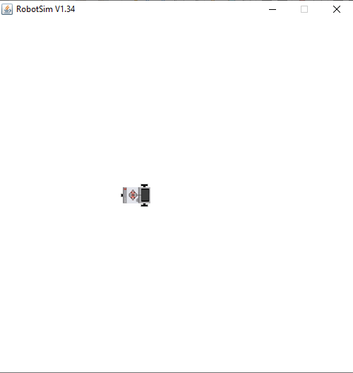

Assignment 1(B):

Aim: Write a program to create a robot to perform circular motion using gears

Description:

1] rightArc() :

Starts to move to the right on arc with given radius. Method returns immediately, while the movement continues.

.

# Code:

import ch.aplu.robotsim.NxtRobot; import ch.aplu.robotsim.Gear; public class assignment1B {

public assignment1B () { NxtRobot r = new NxtRobot (); Gear g = new Gear (); r.addPart (g);

g.setSpeed (100); while (true) {

g.rightArc (0.5);

}

}

public static void main (String [] args){ new assignment1B ();

}

}

# Output:

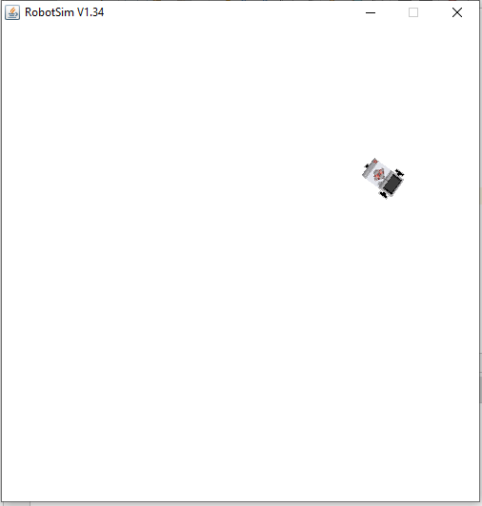

Assignment 2 (A):

Aim: Write a program to create robot to perform a square motion without using gear.

Code:

import ch.aplu.robotsim.*; public class Assignment_2a {

Assignment_2a () {

TurtleRobot t = new TurtleRobot (); t.setTurtleSpeed (100);

while (true){ t.forward(200); t.left (90);

}

}

public static void main (String [] args) { new Assignment_1a ();

}

}

# Output:

Assignment 2 (B):

Aim: Write a program to create robot to perform a circular motion without using gear.

Code:

import ch.aplu.robotsim.*; public class Assignment_2b {

Assignment_2b () {

TurtleRobot t = new TurtleRobot (); t.setTurtleSpeed (100);

while (true) { t.forward (2);

t.left (2);

}

}

public static void main (String [] args) { new Assignment_1b ();

}

}

# Output:

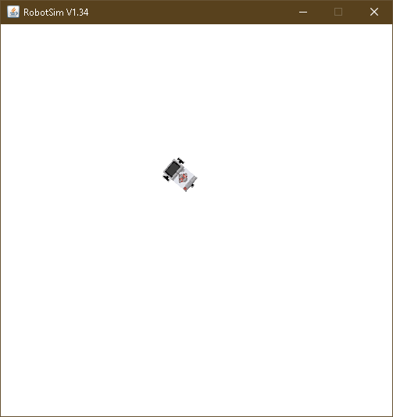

Assignment 3:

Aim: Write a program to do a square using while or for loop, change direction based on condition and control motor movement

Description:

1. Motor() :

Creates a motor instance that is plugged into given port.

1. Tools.delay() :

Suspends execution of the current thread for the given amount of time.

Code:

import ch.aplu.robotsim.*; import java.util.*;

public class assignment2 { assignment2 () {

Scanner sc = new Scanner (System.in); NxtRobot r = new NxtRobot ();

Motor m1 = new Motor (MotorPort.A); Motor m2 = new Motor (MotorPort.B); r.addPart (m1);

r.addPart (m2);

System.out.println ("Enter 1 for left and 2 for right :"); int direction = sc.nextInt ();

switch (direction) { case 1:

for (int i=0; i<4; i++){ m1.forward (); Tools.delay (1090); m2.forward ();

Tools.delay (1090); m1.stop ();

m2.stop ();

}

break; case 2:

for (int i=0; i<4; i++){ m2.forward (); Tools.delay (1090); m1.forward (); Tools.delay (1090); m1.stop ();

m2.stop ();

}

break;

}

}

public static void main (String args[]){ new assignment2 ();

}

}

# Output:

